TECHNICAL PROJECT REPORT

# Title of Invention / Project: anti theft alarm system

# Team Members / Inventors:

|  |  |  |  |  |  |
| --- | --- | --- | --- | --- | --- |
| **S.No.** | **Name** | **Department** | **Designation** | **Mobile** | **E-Mail** |
| 1. | Shiva tanwar  (18BCS4295) | CSE(MC) | Team leader | 8607227108 | shivatanwar63@gmail.com |
| 2. | Sourabh pachar  (18BCS4284) | CSE(MC) | Team member | 8505034188 | sourabhpachar1975@gmail.com |
| 3. | Adish  (18BCS4353) | CSE(MC) | Team member | 6284123589 | adishmaurya05@gmail.com |
| 4. | Saurabh kalita  (18BCS4352) | CSE(MC) | Team member | 9101605398 | saurabhkalitainfinity@gmail.com |
| 5. | Khushal Thakur | ECE | Mentor | 9646030764 | khushal.thakur@cumail.in |
| 6. | Anshul Sharma | ECE | Mentor | 9478697475 | anshulsharma.ece@cumail.in |
| 7. | Kiran Jot Singh | ECE | Mentor | 9463909689 | kiranjotsingh.ece@cumal.in |
| 8. | Divneet Singh Kapoor | ECE | Mentor | 9878422653 | divneet.ece@cumail.in |

Section – 1 (IPR Related)

# Brief Abstract (500 words):

The circuit, construction and setup for the Laser Security System is very simple.

If used with a battery, the laser security system can work even when there is a power outage.

Laser Security System can be used in safety lockers in our homes, where even if the locker’s code is hacked, it acts as an additional layer of security.

Apart from security systems, this laser based setup can also be used to check if pets or babies crossed a certain boundary.

Appointing sequrity guards or personaly being there to protect the property 24/7is practically not possible these security systems provides round the clock protection

Homes and commercial properties that have burglar alarm systems installed are at lesser risk, of being targeted by thief’s when thief’s find out that you have alarm system installed they are persuaded to move away from your property even if they are not aware of its presence the alarming sound will scare them off

There are two types of alarm systems wireless alarm systems work on batteries and not electricity which means they are not effective during power cuts as well

The alarm security device can be disconnected and installed at different places as well its easy to relocate both wired as well as wireless alarm security systems

# Existing state-of-the-art and Drawbacks in existing state-of-the-art

(*Brief background of the existing knowledge*)

|  |  |  |
| --- | --- | --- |
| **S. No.** | **Existing state of art** | **Drawbacks in existing state of art** |
| 1 | Laser alarm security system | Lasers are sensitive. That is great because it means they don’t miss much. But unfortunately, it also means they can’t differentiate between a genuine threat (of a human) and, for example, a cat |
| 2 |  |  |

# Novel/Additional modifications that you can propose to improve upon drawbacks

*(List down the features)*

* Feature 1 FALSE ALARMS-these security systems are prone to false alarms that involves alarm ringing when anyone form your family enters the restricted area or there are instance when the alarm is triggered on by itself
* Feature 2 CAN BE STOLEN it can be stolen from the site from where it is installed some thefts can easily disconnect the wired alarm system

# Advantages

(*List down the advantages, if each feature is incorporated)*

* Adv 1 CAN RELOCATE-the alarm system can be disconnected can be installed at different places its easier to relocate alarm system
* Adv 2 UNINTERRUPED FUNCTIONALITY-these type of alarm systems work in batteries it means they are effective during power cuts

Section – 2 (Real Project)

# Materials

(*List down the Components, Equipment, etc. actually used in the project*)

BC 547 TRANSISTOR,9V BATTERY,CONNECTING WIRES ,BREADBOARD,RESISTOR,LED

# Circuit Diagram

(*Fully functional circuit diagram with exact connections. Can use Fritzing/Proteus*)

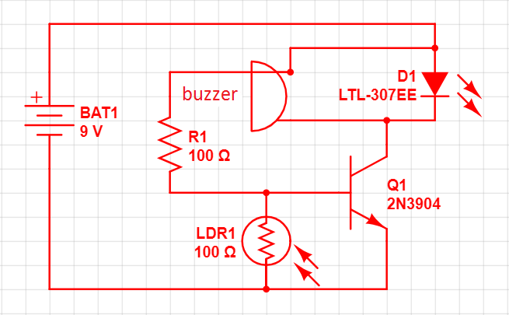

# Steps of Circuit Completion

(*Bifurcate the circuit completion in steps, specify with photographs, leading to final project*)

### **Step 1**

**Tracing the circuit**

Take a permanent marker and make a rough layout of the circuit

### **Step 2**

Find the location of electronic components from layout and placing them carefully on their respective positions.

### **Step 3**

**Final step**

Carefully placed the battery After checking the circuits again for proper placement, press the switch ‘ON’.

Now, when you put your finger in front of laser, you will find that the buzzer would turn on thus producing an alarm. When you ‘OFF’ the switch the buzzer will not make any sound.

# Program Code

(*Link of your Github project*)

https://github.com/sourabh9101/ANTI-THEFT-ALARM-SYSTEM.git